**COSC1295 Advanced Programming**  
Assignment 2 Report

Name: Robin Yao Long Tay

Student id: s3558127

**Design Outline**

* Simple interface  
  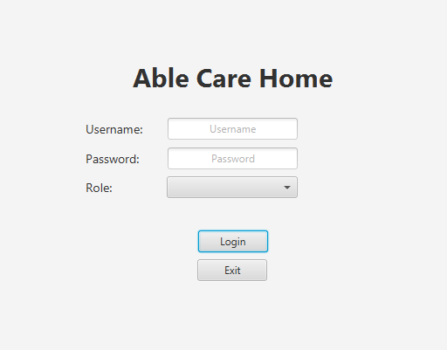
* Manager fixed login username and password (admin)

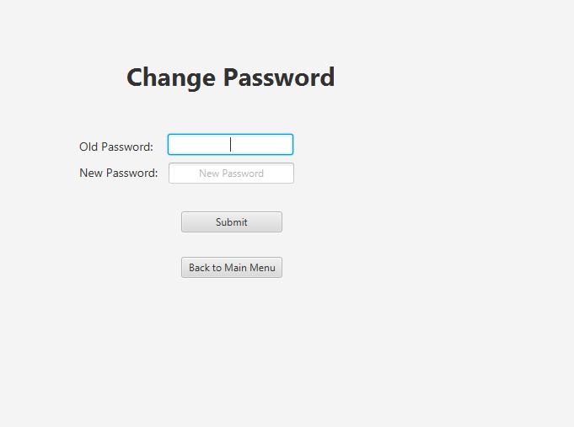

* All user id start with significant alphabet (e.g. Doctor: d123, Nurse: n32, Patient: p13, Shift: s2) 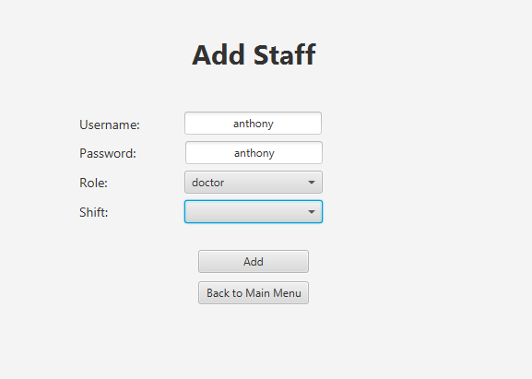
* Easy to use since text box call out all the data

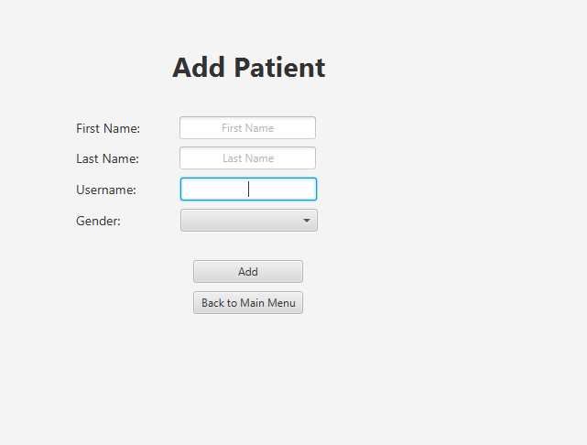

* Click bed for details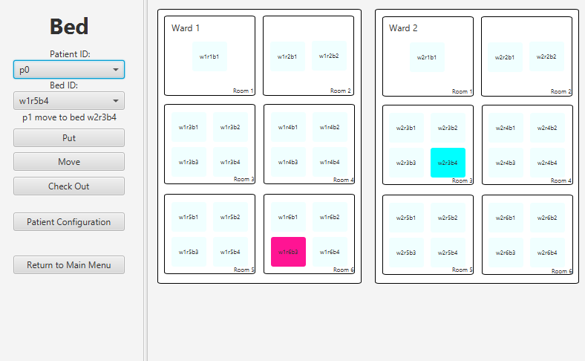
* Ease of verification before changing password 
* Ease of changing or adding shift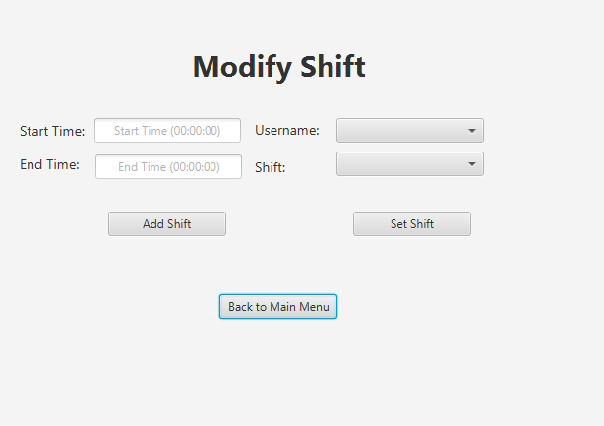
* Easy patient configuration interface

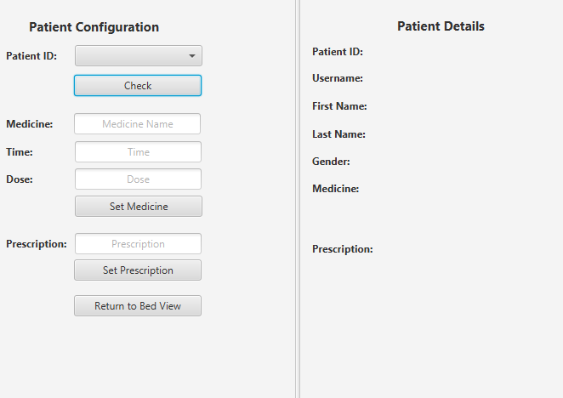

**Refactoring Report**

* Check login detail make it simple to all verification 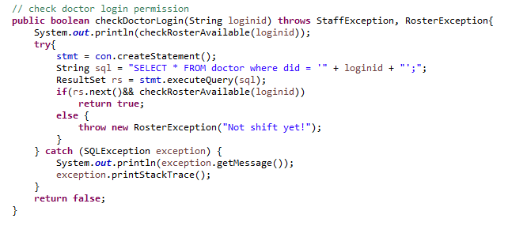
* Check roster for all 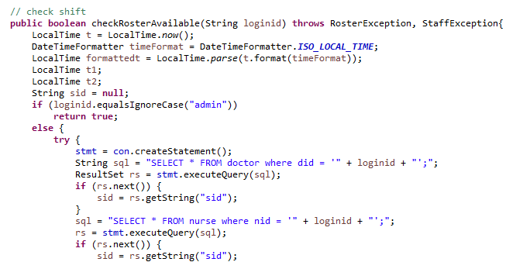
* Initializing all back end and connect to database 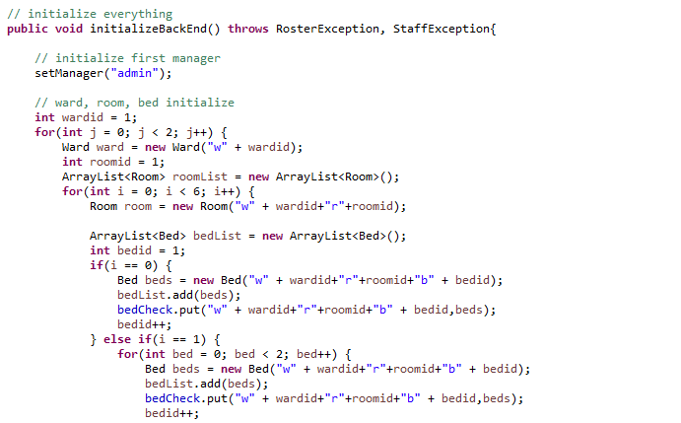
* Added two new table to remember user login for remember password or username every time the app restart 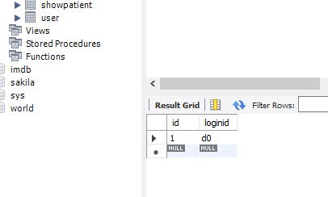
* All table id start with relevant alphabet 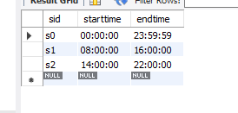 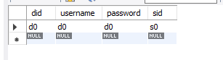 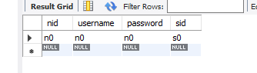 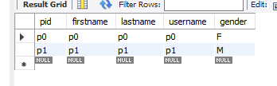
* One method of change scene use in all controller  
  